**CASE STUDY - 3:** Create an VPC attach to it Lambda and attach RDS to that Lambda

Step1: Create VPC , create 5 subnets , 3 public and 2 private subnets in 2 availability zones us-east-2a , us-east-2b in region Ohio (us-east-2 ). Resource map is shown below

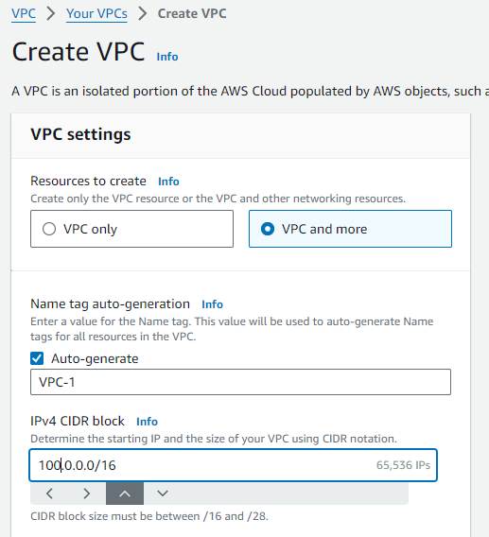

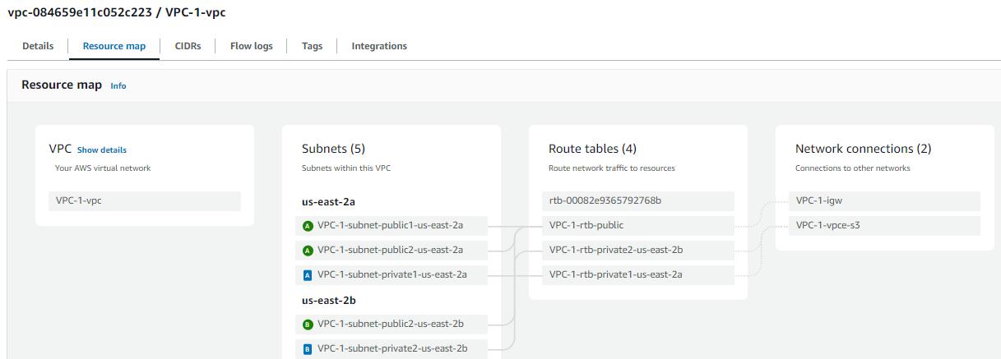

Step-1 : go to Lambda function , click on create a function

secut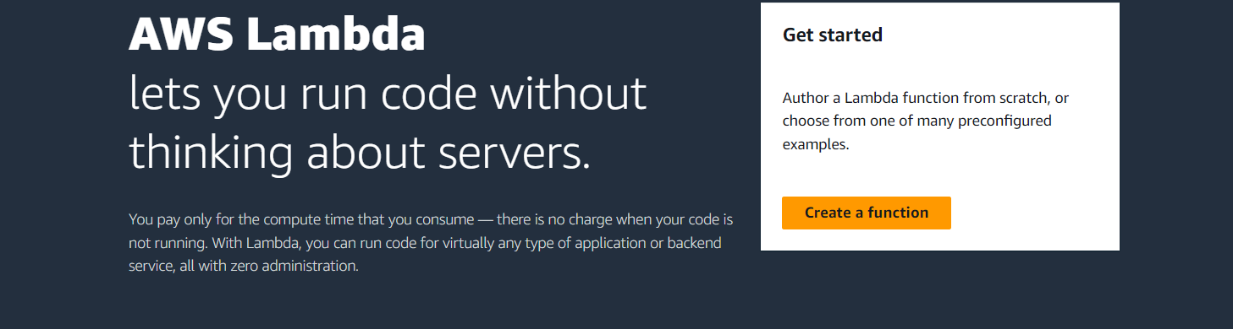

step 2 : While creating a function click on enable VPC , select 2 public subnets in same region, select existing security group

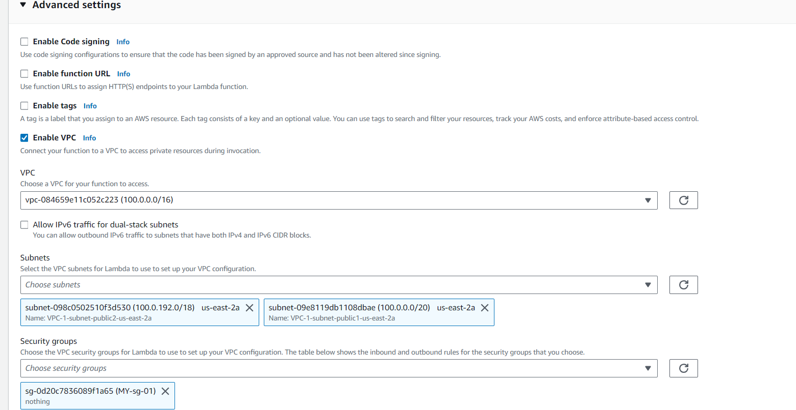

Now lambda function is created .

Step-3 : Go to RDS , create a subnet group

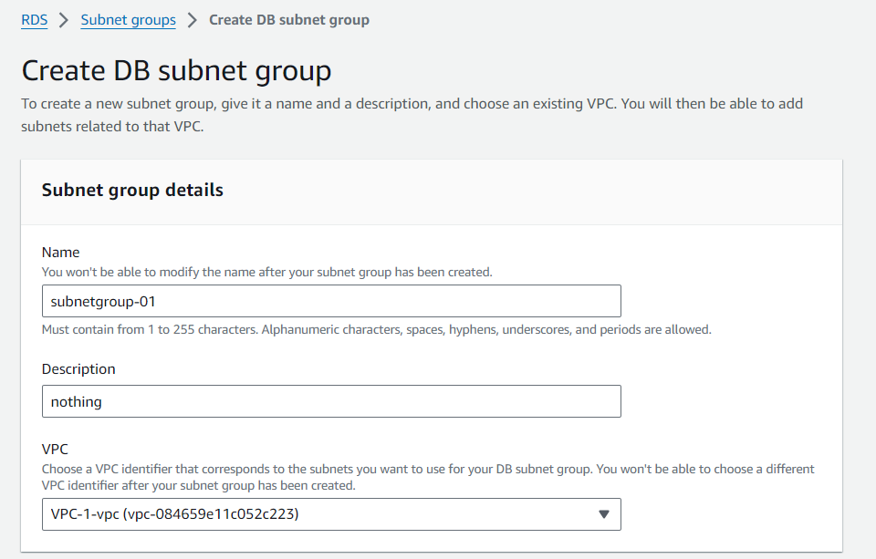

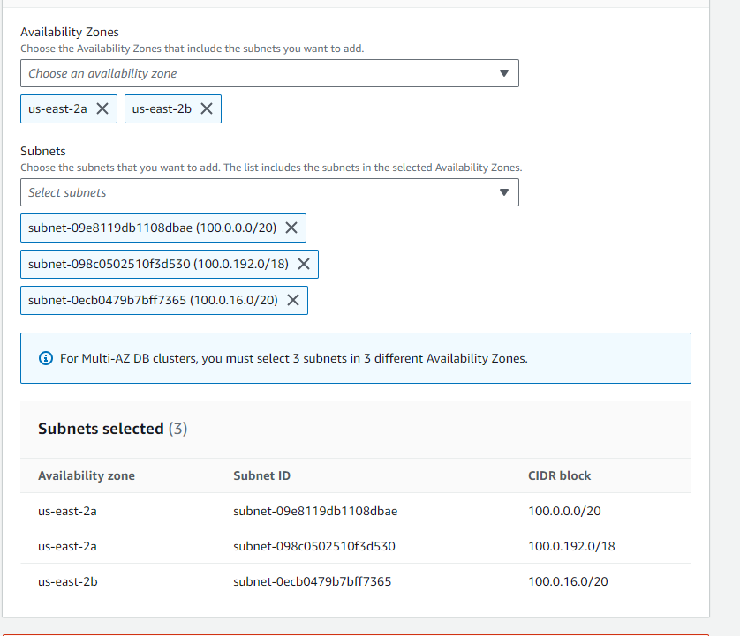

Subnet group is created

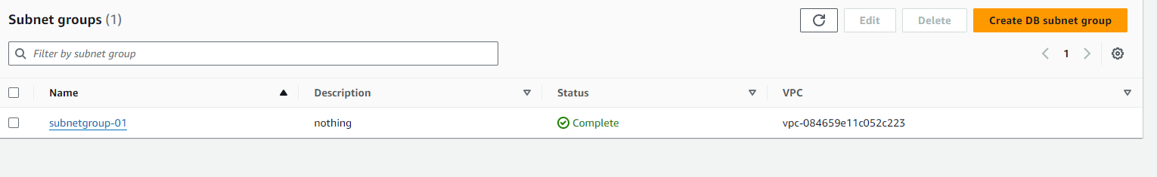

Step -4 : Create Proxy:

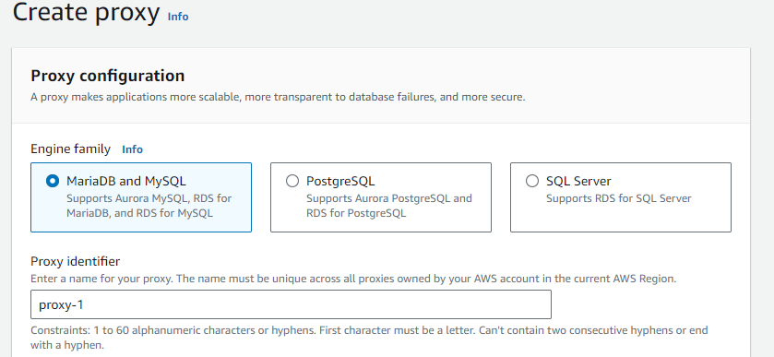

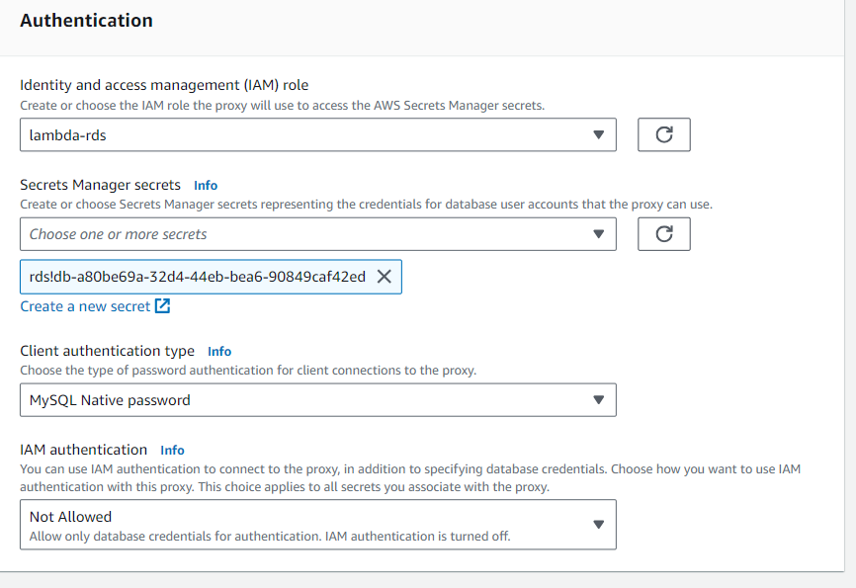

Step-5 : Now go to configuration tab, click RDS database in the left panel then click on connect to RDS Database

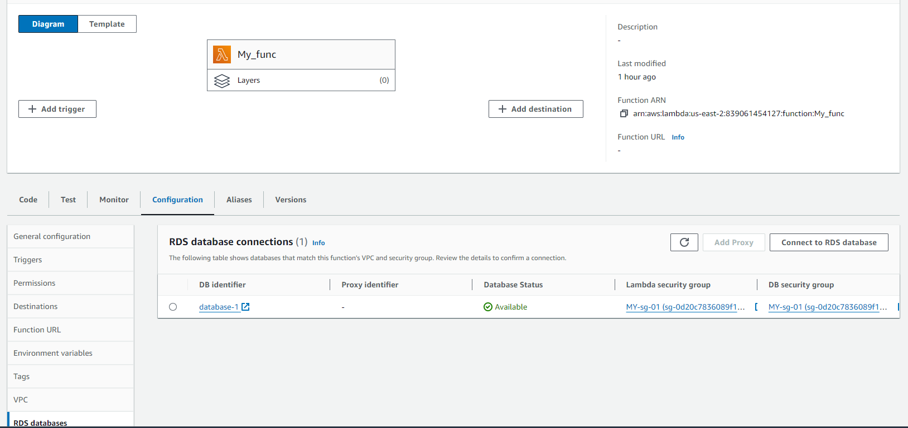

Step-6 : Select use an existing database. Select the created database i.e database-1. Click on Create button

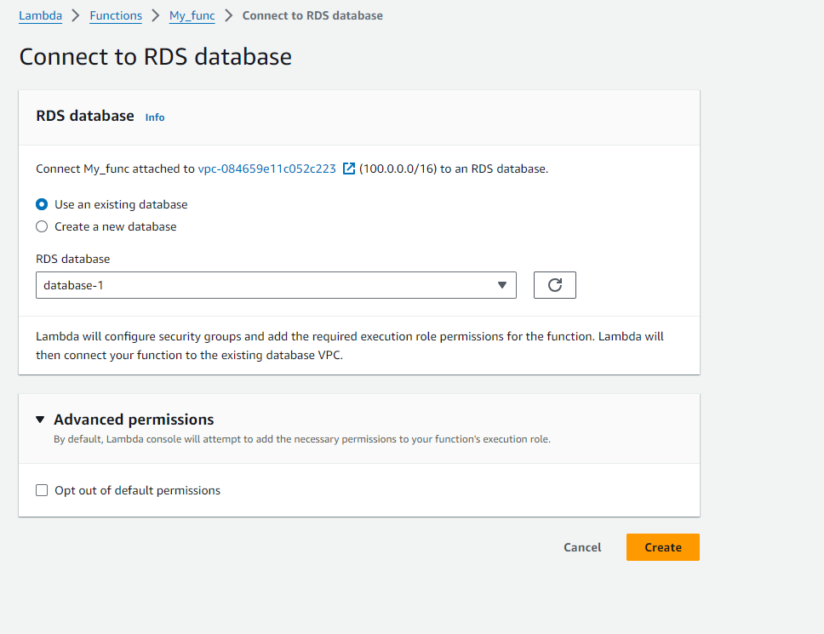

Step-7 : After connecting to RDS database . Click on Add Proxy



Step 8 : Select the existing Proxy and click on Add button

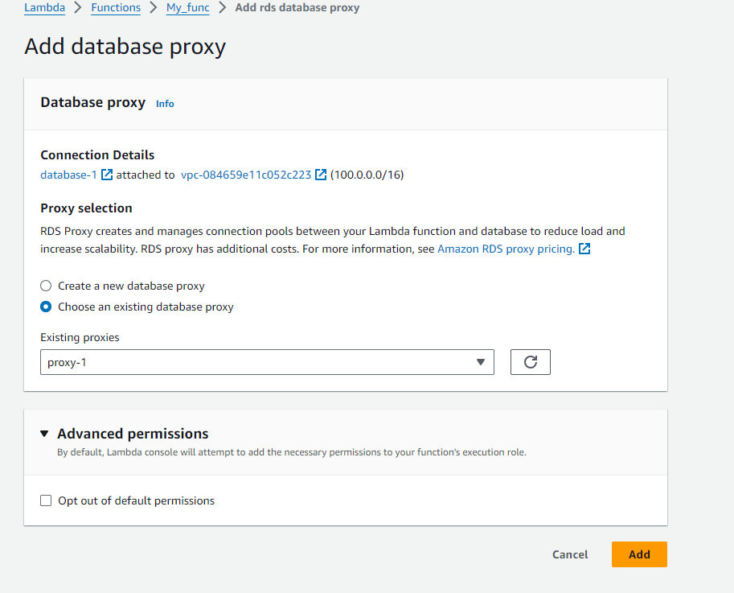

Step -9 : Finally we have created a VPC attached to Lambda and attached RDS to that Lambda

